MCCORMICK ELEMENTARY SCHOOL

PBIS MATRIX

CHIEF’s  will always:  CARE 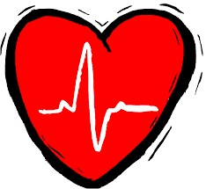 | CHIEF’s  will always:  demonstrate HARD  WORK | CHIEF’s  will always:  show INTEGRITY | CHIEF’s  will always:  demonstrate  EXCELLENCE  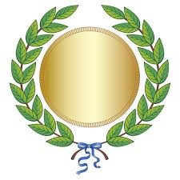 | CHIEF’s  will always:  FOCUS 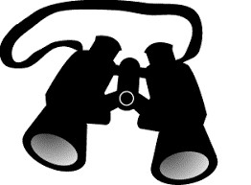 | CHIEF’s  will always:  Be STEADFAST  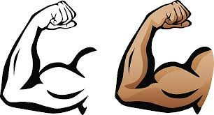
Cover your mouth when you sneeze or  Cough, then say excuse  me | Transition Quickly, quietly, and orderly | Keep yourself and the bathrooms clean and germ free | Face forward, stay seated, and be quiet on  the bus | Hold the door for people rather than letting it close on them | Walk in our building on the blue line on the  right side
Respond to adults | Make eye contact with anyone speaking | Respect other’s comments, opinions and ideas | Do not show disrespect with gestures | Follow along when we read in class | Keep your hands, feet and objects to yourself unless instructed otherwise.
Congratulate classmates | Complete homework and classwork daily | Never ask for a reward | Say thank you when given something and  never insult the giver or  gift | Ask a question in return  if you are asked a question in a conversation | Follow all classroom procedures and protocols all of the time.
Surprise people with random acts of kindness | Answer all written questions in complete sentence | Never brag, if you win, Never show anger if you lose | Be organized | Never moan or complain when assignments are given | Be positive and enjoy life

